Overview of peripherals theory day1 :

Task 1:

Inkjet Printer :
Printing family photo albums
Laser Printer :Producing high-volume office reports
3D Printer :Creating custom prototype parts for engineering
Flatbed Scanner: Digitizing old photographs and documents
Sheet-fed Scanner :Processing multi-page contracts for digital archives
Webcam: Hosting remote team meetings
Streaming Webcam : Broadcasting live gaming sessions on platforms like Twitch

TASK 2:
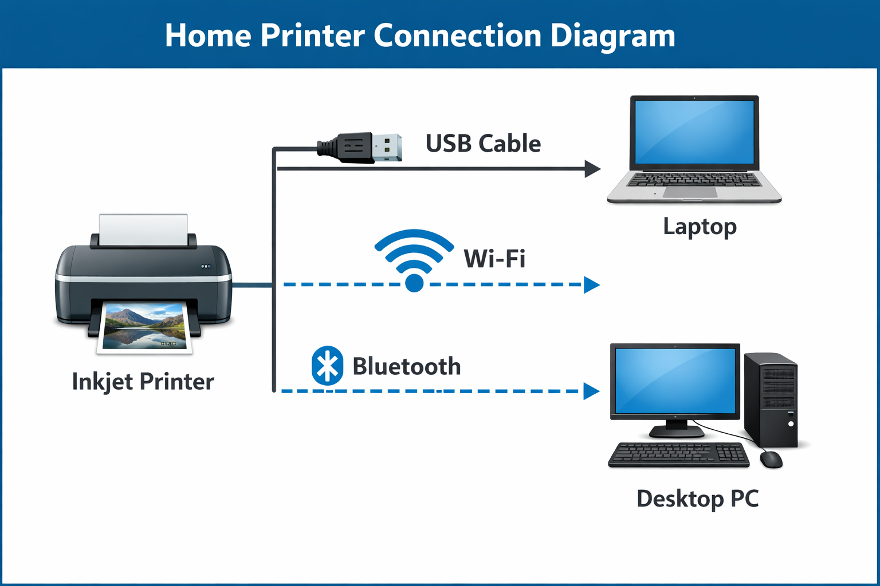

USB connection :direct , reliable ,wired
WI -FI Connection : wireless , allow multiple device to share printer
Bluetooth connection : short range wireless.

TASK 3:

Connection  Interface | Advantage | Disadvantage
USB | Fast data transfer and stable connection | Limited cable length restricts placement flexibility.
Wi-Fi | Wireless convenience; multiple devices can connect simultaneously. | Can suffer from interference or slower speeds on congested networks.
Bluetooth | Easy short-range pairing without cables. | Lower bandwidth and range compared to Wi-Fi or USB.

TASK 4: for USB port
- Locate the USB port : Find the rectangular USB Type-B port on the back of your printer and the USB
Type-A port on your computer.
- Plug in the cable :
Insert one end of the USB cable into the printer and the other into your computer’s USB PORT

- Power on the printer : Switch on the printer. Your computer should automatically detect the new device.
- Install drivers
(a)If prompted, allow Windows or macOS to install the printer driver automatically.
(b)Alternatively, download the latest driver from the manufacturer’s website.
- Test the connection : Open a document and print a test page to confirm successful setup.

